Byron Laferriere
DAD-220
Professor Gupta
15 May 2020

1) Connect to the Database:
- sudo mysql -u root -p
- show databases;
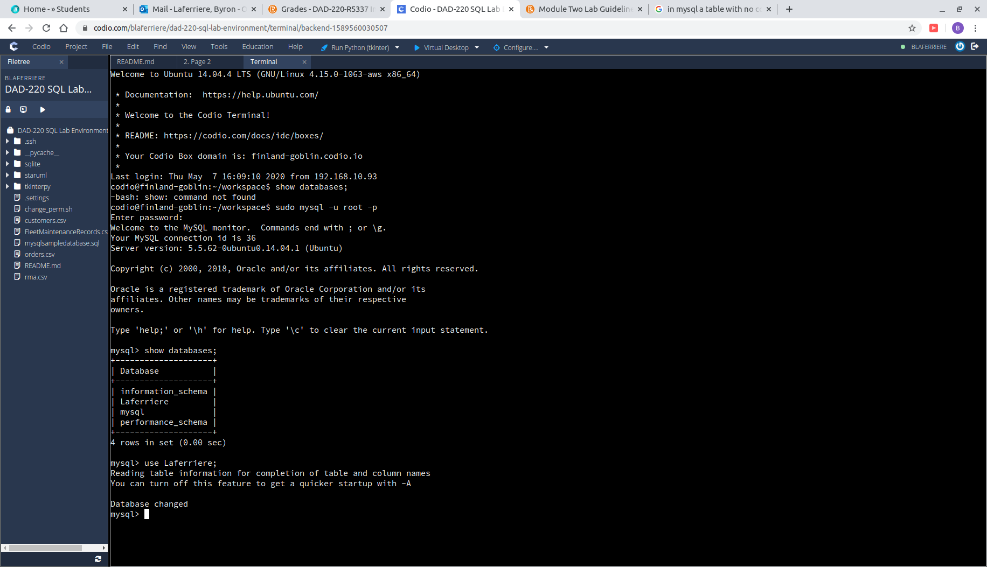
- use Laferriere;

2) Create the Employee Table:
- CREATE TABLE Employee (
- -> Employee_ID SMALLINT,
- -> First_Name VARCHAR(40),
- -> Last_Name VARCHAR(60),
- -> Department_ID SMALLINT,
- -> Classification VARCHAR(10),
- -> STATUS VARCHAR(10),
- -> Salary DECIMAL(7,2));

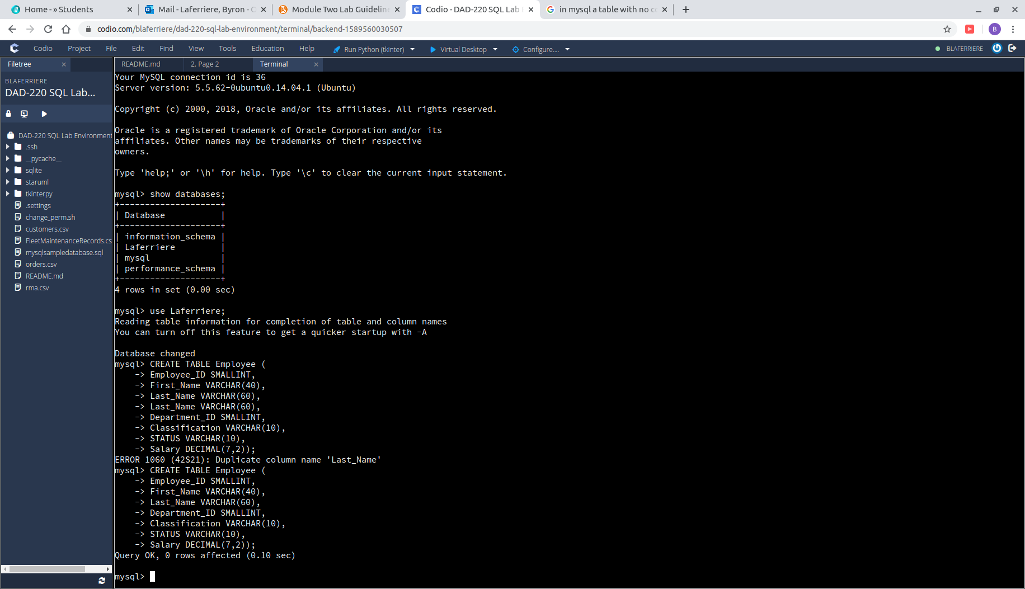
3) Create the Branches table:
- CREATE TABLE Branches (
- -> Department_ID SMALLINT,
- -> Department_Name VARCHAR(50));

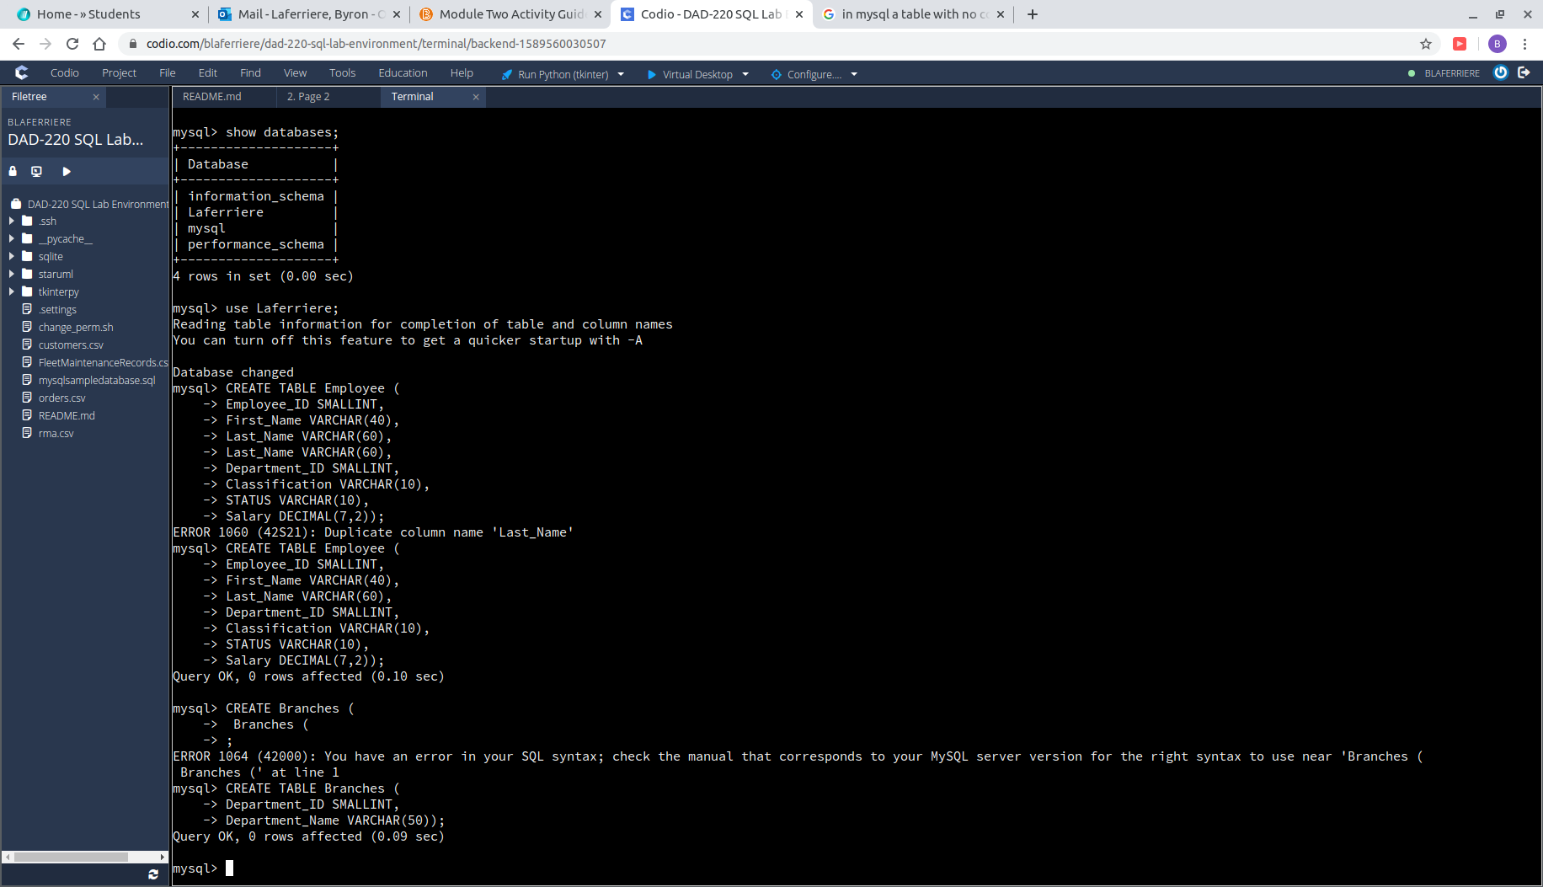
4) After creating the tables, use the correct commands to describe them:
- DESCRIBE Employee;
- DESCRIBE Branches;
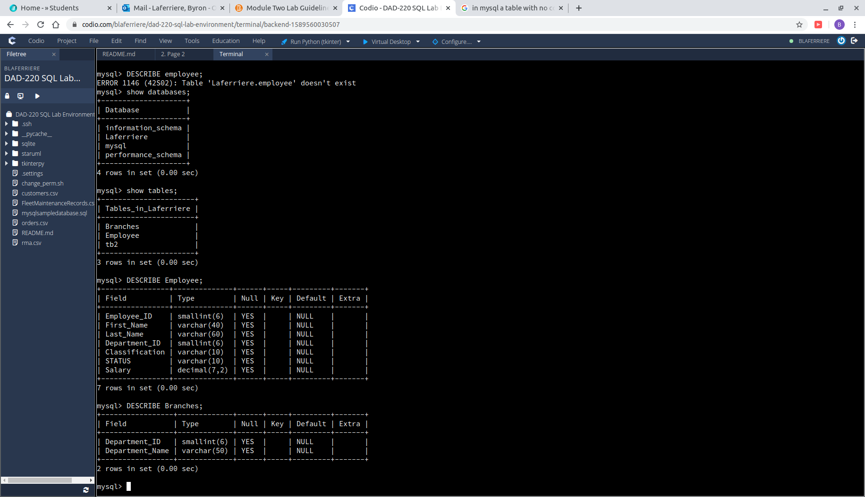

5) Insert the following records in the Employee Table, then use SELECT * FROM Employee;
- INSERT INTO Employee VALUES (100,'John','Smith',1,'Exempt','Full-Time',90000),(101,'Mary','Jones',2,'Non-Exempt','Part-Time',35000),(102,'Mary','Williams',3,'Exempt','Full
-Time',80000);
- SELECT *
-> FROM Employee;
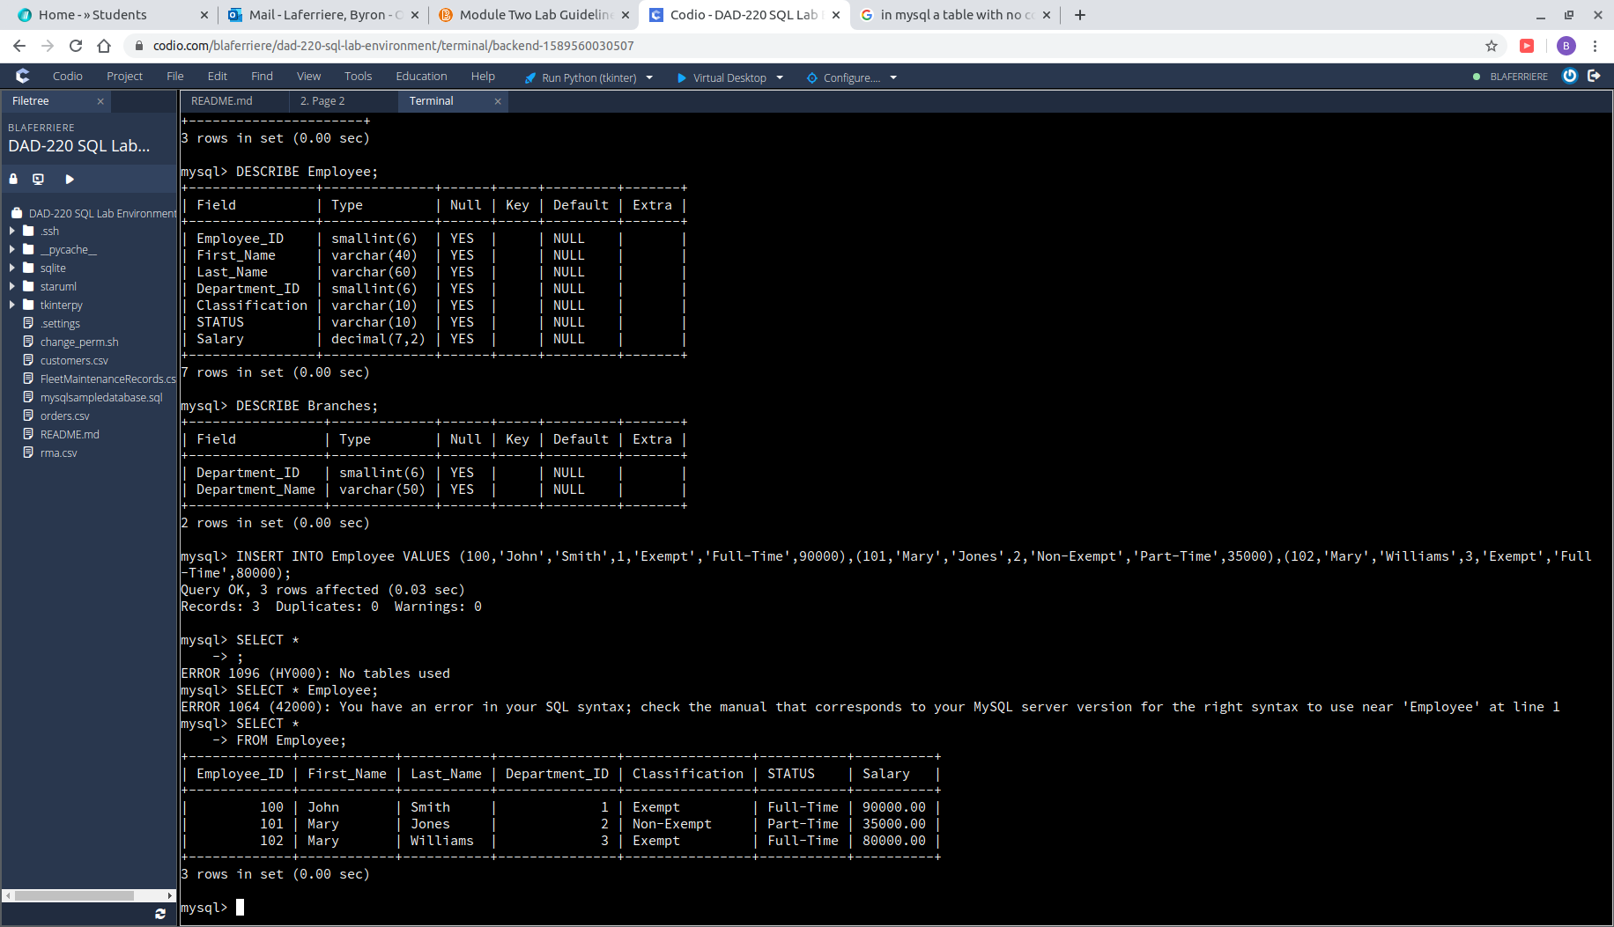

6) Insert the records for Gwen Johnson, Michael Jones, Byron Laferriere, Elon Musk:
- INSERT INTO Employee VALUES (103,'Gwen','Johnson',4,'NULL','Full-Time',40000 ),(104,'Michael','Jones',4,'Non-Exempt','Full-Time',90000),(105,'Byron','Laferriere',1,'Non-ex
mpt','Full-Time',99000);
- INSERT INTO Employee VALUES (106,'Elon','Musk',1,'Non-Exempt','Full-Time', 50000);
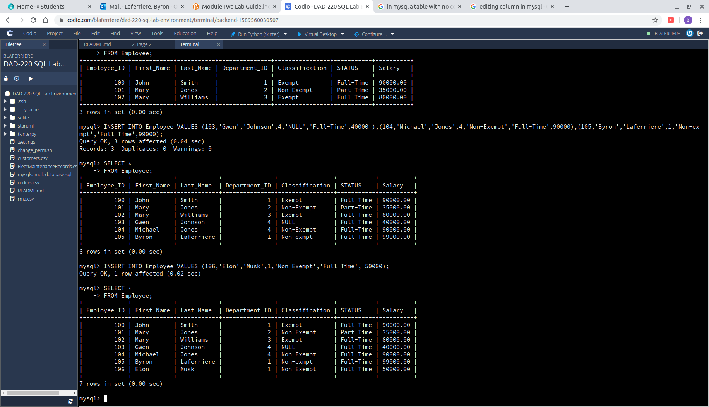
7) Select the fields First_Name, Last_Name, and Department_ID from Employee table;
- SELECT First_name, Last_Name, Department_ID
-> FROM Employee;
